Year 10 - Forces and Motion Revision Notes
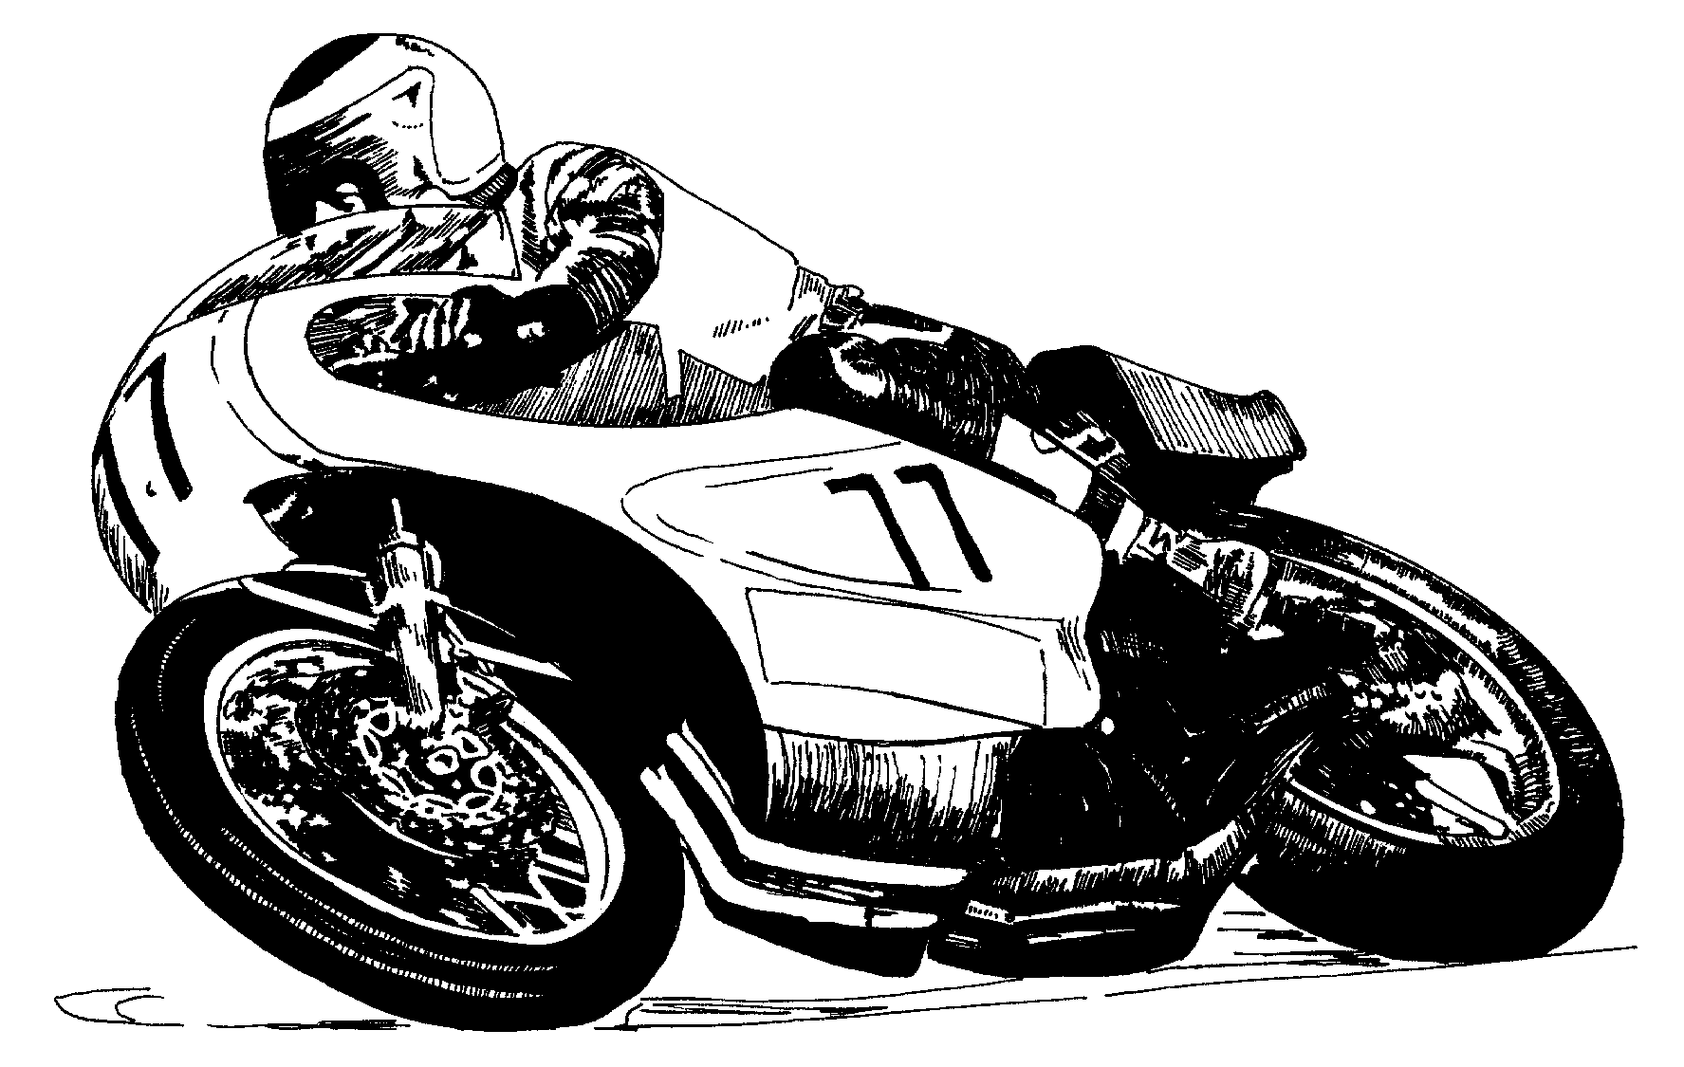

MOTION

Speed is how fast an object is moving

v_{av} is average speed of object d is distance travelled t is time taken to travel distance
in m/s (or units used for d & t) in meters in seconds
or m.s⁻¹

v_{av} = d/t

Example: Car travels at 800 m.s⁻¹ for 1 minute. How far did the car travel? d= v x t
d =800 x60 = 160m

Acceleration is the rate at which speed is changing

a is acceleration of object v is change in speed t = time taken to change speed
in m.s⁻² in m/s or m.s⁻¹ in seconds
a = v / t

Example: An object travelling at 25 m.s⁻¹ increases speed to 65 m.s⁻¹ in 5 seconds. What is the acceleration? a = v / t a = 65 – 25 / 5 = 40 / 5 = 8 m.s⁻²

Distance – Time Graphs

Slope gives speed of object.
- Straight line = constant speed Curved line = increasing speed

d
(m)

t (s)

Speed – Time Graphs

Slope gives acceleration of object
- Straight line = constant acceleration Curved line = increasing acceleration

FORCES

- Forces are pushes or pulls.
- A force has a size and a direction, shown by an arrow.
- Symbol F
- Unit newton (N)
- Net Force is the combined effect of all forces on an object.
- Forces in the same direction add together.
- Forces in opposite directions subtract.
- Weight force is force due to gravity. F = m x g g = 10 m.s⁻² m = mass
- Friction force opposes motion of object. Often causes heat.

Balanced Forces Unbalanced Forces

Combined effect (net force) is zero. Combined effect (net force) is not zero
Object remains stationary or has Object accelerates in the direction of the net force
constant speed.

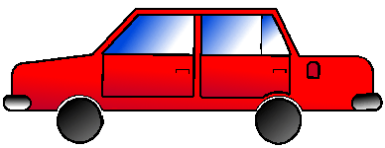

- Calculate acceleration caused by unbalanced forces

F = m x a

F is net force on object in newtons
m is mass of object in kilograms
a is acceleration on object in metres/sec/sec (m.s⁻²)

Calculate the acceleration of the above car if its mass is 1000 kg and net force acting is 250 N.
a = F/m a = 250/1000 a = 0.25 m.s⁻²

WORK AND POWER

Work
- Work is the amount of energy transferred when an object is moved over a distance.
- Work is only done when a force moves the object.

W = F x d
W is work energy transferred to object, in joules
F is the force moving the object, in newtons
d is the distance object moves, in metres

Examples:
1. A person pushes a toy car is pushed 2m across the floor with a force of 800 joules. Calculate the work done by the person.
W = F x d W = 800 x 2 = 1600 J
The toy car has gained 1600 J of Kinetic Energy
- A weight lifter lifts a 50 kg box from ground to a height of 2m. What is the work done by the weightlifter?
The 50 kg box needs a force of 500N to lift it against gravity (F = m x g F = 50 x 10)
W = F x d W = 500 x 2 = 1000N
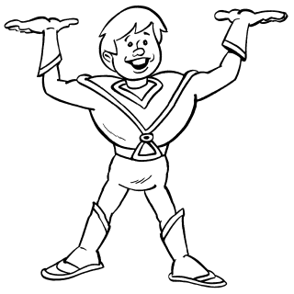The box has gained 1000N of Gravitational Potential Energy

Energy transfers above assume no energy lost to friction.

Power

- Power is the rate that work is done.
- Symbol P
- Unit watt (W)
- 1 watt means 1 joule of energy transferred (work done) each second.

P = W / t

P is power of machine in watts
W is work energy transferred to object, in joules
t is time taken to transfer energy, in seconds

Examples:
- Calculate the power output of the weightlifter above if box is lifted in 2 seconds.
P = W/t P = 1000 / 2 = 500 W
- Calculate power output of a crane that lifts 800kg of concrete a height of 10m in 20s.
F = m x g F = 800 x 10 = 8000N
W = F x d W = 8000N x 10 = 80000J
P = W/t P = 80000 / 20 = 4000W

Momentum
- Momentum is the tendency of objects to keep moving once they are in motion.
- Units kg.m.s⁻¹
m is mass, in kg v is objects speed, in m/s (ms⁻¹)
momentum = m x v

